# INTRODUCTION

In most of the university and colleges attendance of students is important factor, checking student attendance is the important issues because all universities evaluate student’s attendance while them giving final grade. Some colleges use paper sheet for student attendance and after that fill all this information manually in college server. This all are time consuming process like calling particular student then fill all information, and student give the proxies of their friends even they absent. By considering all this issue we develop one system which get attendance and update attendance in one place. Our paper presents near field communication technology to get the attendance of students in school and colleges. The system is based on NFC Technology and run on mobile as application, this paper presented details of this system.

This paper introduces a Near Field Communication (NFC) supported collage attendance system for college students. In the most of collages lecturer take attendance by calling out the names and surnames of students and then marking them or pass the attendance sheet to students and asking students to sign in attendance sheet. This both practices have their drawbacks. In first case if strength of students are more, checking all these student by name and surname might take about several minutes. In second case if student is absent then friends of absent students may write down their name and surnames. These practices place college institutions at considerable disadvantages when it comes to taking attendance. To come out from all these issues we put NFC tag into service. Each tag has a unique ID, precluding the duplication of a tag. These NFC tag are given to students when they registered in college. When student enter in class rooms and touch or move these tag on lecturer mobile phone, NFC readers program will read these tags, identify the students from their respective NFC tag and embedded camera will capture the face of particular student then application send all the data to college server and in server side validation program will check the data for validation (compare new data with previous data which was already store in database) if valid data found then program will update the database as marking attendance otherwise mark student is absent. These all done with one system no manual working this means no class time will be wasted

# OVERVIEW OF THE STUDENT ATTENDANCE SYSTEM

The main objective of our project is to take information about the attendance of students to lectures. The manual process, signing in a signing sheet is not sustainable and accurate it also takes more time in this process as more the students the more time will be taken so due to these failures of this manual system we tend to see this alternative will make more success and improves efficiency of the system. And also with the development of technology our method tends to make the system updated with the technology.



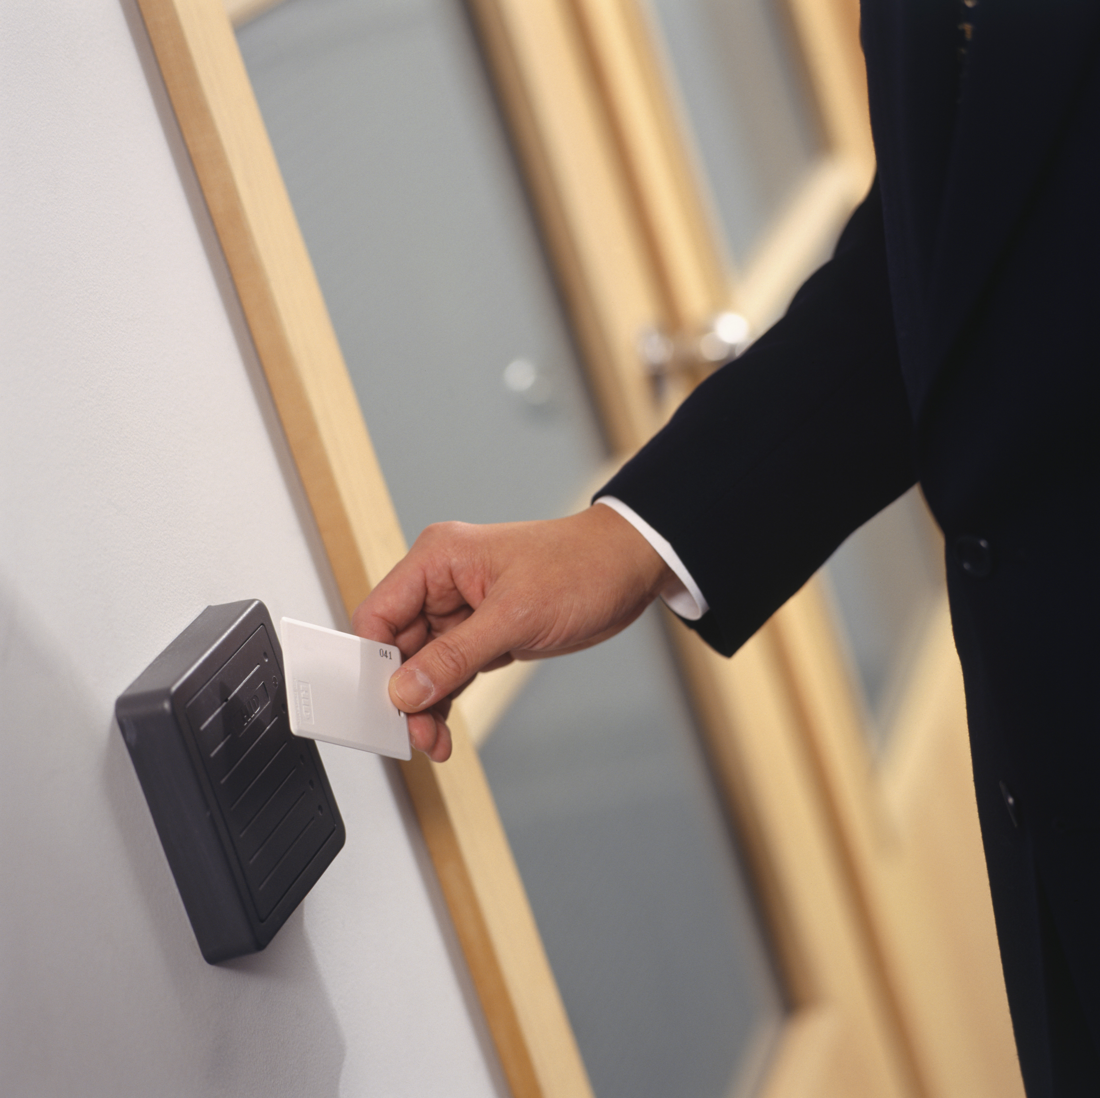

What our system do is, students will be given with a NFC card, every day before students participate to lectures via NFC card their attendance will be marked as they wipe their card in our system, alone with the time, date they attend to the lecture.

# COMPONENTS WE NEEDED

## HARDWARE

* Node MCU
* Radio Frequency Identification module
* RFID tags and cards
* RGB LED s
* Buzzer
* Jumper wires
* BreadBoard
* A Wi-Fi network

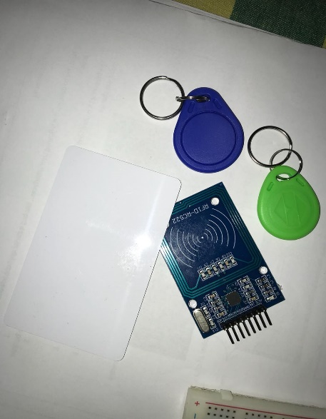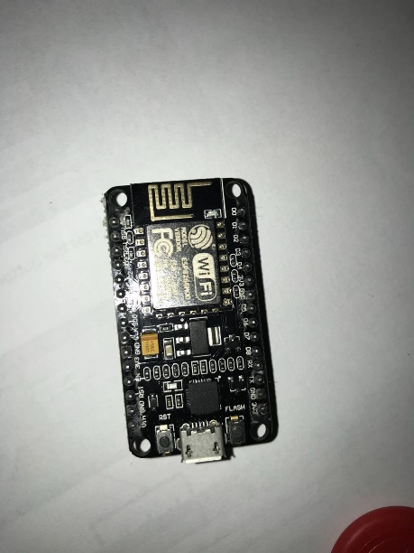

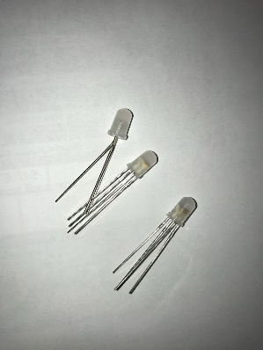

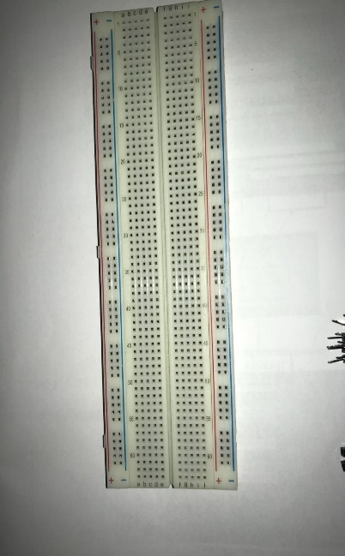

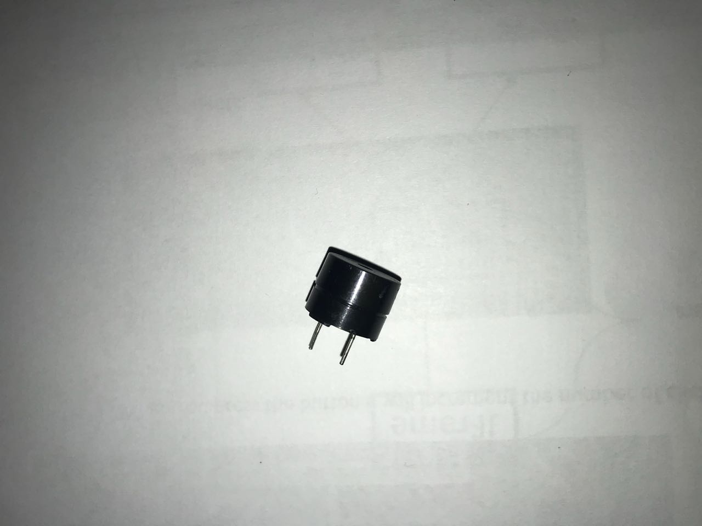

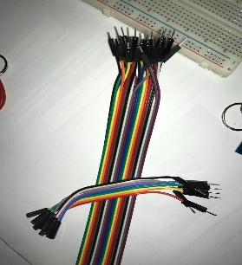

## SOFTWARE

* Arduino IDE
* Apache server
* MySQL server
* A web browser

# HOW OUR SYSTEM WORK

* There is a unique frequency attached with every card that uniquely identify that card from others.
* 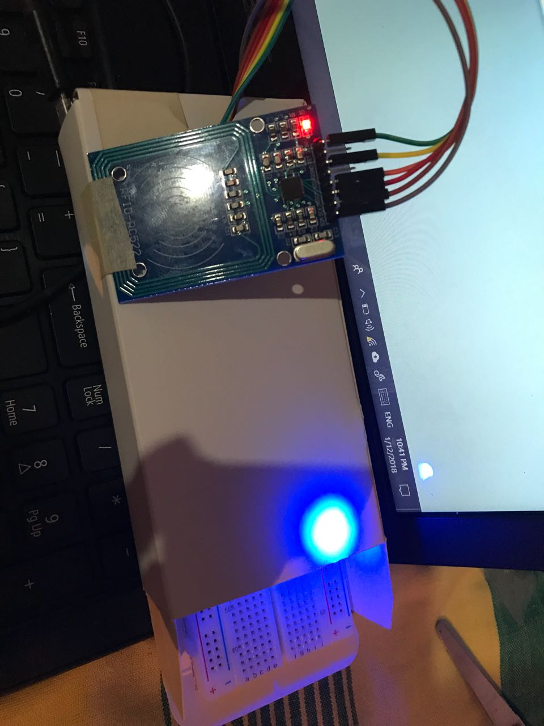Through that frequency as we wipe the card to the system, the systems run that frequency through the database and get the student registered with that frequency and display on the web interface with the login time and the display name.

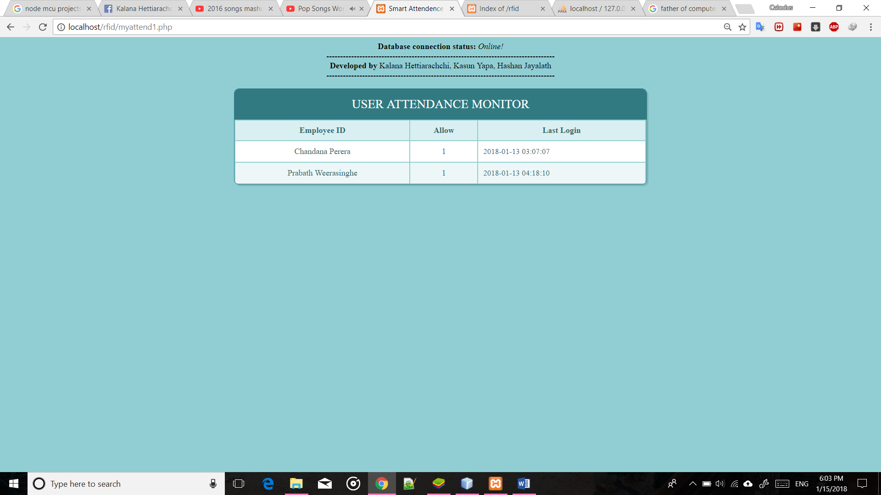

# BLOCK DIAGRAM

# 

Block diagram was drawn by using <https://draw.io>

# LIMITATIONS OF THE CURRENT SYSTEM

* Students can cheat using the current system, by adding false signatures
* Inefficient, it takes so much time to fill signatures in a signing sheet when the number of students get increased.

# ADVANTAGES OF THE PROPOSED SYSTEM

* Real time information of the students
* Reduces the time wasting
* Improves environmental quality because don’t use paper sheets or other things.
* Increase the efficiency of the administration system

# SOURCE CODES

## NodeMCU

#include <SPI.h>

#include <Wire.h>

#include <MFRC522.h>

#include <ESP8266WiFi.h>

#define SS_PIN 2 // D4

#define RST_PIN 16 // D1

#define No_Of_Card 4 // number of RFID cards

#define UID_Size 4 // UID lenght

#define Buzzer 15 // D8

#define BlueLed 0 // D2

#define GreenLed 4 // D3

const char* ssid = "NStudents"; // SSID

const char* password = "nstudents321"; // Password

char host[] = "192.168.1.109"; // host my computer wifi adpter

const int httpPort = 80; // WiFiClient client;

MFRC522 RFID(SS_PIN, RST_PIN);

MFRC522::MIFARE_Key key;

WiFiClient client;

byte id[No_Of_Card][UID_Size] = {

{17, 01, 215, 43},//Kalana

{117, 170, 82, 171},

{124, 013, 171, 137},

{124, 13, 171, 137}

};

int x = 0;

int count[2] = {0, 0};

byte id_temp[3][3];

//String ID[3] = {"170121543", "124013171137", "11717082171"};

String ID = "170121543"

void setup() {

Serial.begin(115200);

SPI.begin();

RFID.PCD_Init();

pinMode(Buzzer, OUTPUT);

pinMode(BlueLed, OUTPUT);

pinMode(GreenLed, OUTPUT);

for (byte i = 0; i < 6; i++) {

key.keyByte[i] = 0xFF;

WiFi.begin(ssid, password);

Serial.print("connecting");

while (WiFi.status() != WL_CONNECTED) {

Serial.print(".");

delay(500);

}

if (WiFi.status() == WL_CONNECTED) {

digitalWrite(Buzzer, HIGH);

digitalWrite(BlueLed, HIGH);

delay(300);

digitalWrite(Buzzer, LOW);

//digitalWrite(BlueLed, LOW);

}

Serial.println();

Serial.print("connected: ");

Serial.println(WiFi.localIP());

}

void loop() {

if (!RFID.PICC_IsNewCardPresent()) {

return;

}

if (!RFID.PICC_ReadCardSerial()) {

return;

}

for (int i = 0; i < 4; i++) {

id_temp[0][i] = RFID.uid.uidByte[i];

delay(50);

}

for (byte i = 0; i < No_Of_Card; i++) {

if (id[i][0] == id_temp[0][0]) {

Serial.print("Card UID :");

digitalWrite(Buzzer, HIGH);

for (int j = 0; j < RFID.uid.size; j++) {

Serial.print(RFID.uid.uidByte[j], DEC);

}

x = i;

Serial.println(" UID is Valid");

digitalWrite(Buzzer, HIGH);

digitalWrite(GreenLed, HIGH);

digitalWrite(BlueLed, LOW);

delay(150);

digitalWrite(Buzzer, LOW);

digitalWrite(GreenLed, LOW);

digitalWrite(BlueLed, HIGH);

sendRequest(x);

RFID.PICC_HaltA();

RFID.PCD_StopCrypto1();

return;

}

else {

Serial.println("UID is Invalid");

//Serial.println("UID is Invalid");

digitalWrite(Buzzer, HIGH);

digitalWrite(GreenLed, HIGH);

delay(350);

digitalWrite(Buzzer, LOW);

digitalWrite(GreenLed, LOW);

}

}

RFID.PICC_HaltA();

RFID.PCD_StopCrypto1();

}

void sendRequest(int n) {

if (!client.connect(host, httpPort)) {

Serial.println("Connection failed");

return;

}

/*-----------------------*/

// We now create a URI for the request

String url = "/RFID/get.php?emp_id=";

//url += ID[n];

url += ID;

url += "&allow=1";

Serial.print("Requesting URL: ");

Serial.println(url);

// This will send the request to the server

client.print(String("GET ") + url + " HTTP/1.1\r\n" + "Host: " + host + "\r\n" + "Connection: close\r\n\r\n");

unsigned long timeout = millis();

while (client.available() == 0) {

if (millis() - timeout > 5000) {

Serial.println(">>> Client Timeout !");

client.stop();

return;

}

}

}

## Web Interface

<!DOCTYPE html>

<html lang="en">

<head>

<meta charset="UTF-8">

<meta http-equiv="refresh" content="5">

<?php require_once('inc/connection.php'); ?>

<title>Smart Attendence System </title>

<?php

$atten_list = '';

$query = "SELECT * FROM attendence ";

$result = mysqli_query($connection, $query);

$row = mysqli_fetch_array($result, MYSQLI_ASSOC);

while($row = mysqli_fetch_array($result))

{

//$atten_list .= "<tr>" .

$atten_list .= "<td>" . $row['emp_id'] . "</td>";

$atten_list .= "<td>" . $row['allow'] . "</td>";

$atten_list .= "<td>" . $row['last_login'] . "</td>";

$atten_list .= "</tr>";

}

?>

<link rel="stylesheet" href="css/style.css">

</head>

<body>

<div class="table-users">

<div class="header">USER ATTENDANCE MONITOR</div>

<table cellspacing="0">

<div class = "scroll" >

<table id="Attendence">

<tr>

<th><b>Employee ID</b></th>

<th><b>Allow</b></th>

<div id="last_login">

<th><b>Last Login</b></th>

</div>

</tr>

<?php echo $atten_list; ?>

</table>

</div><!--scroll-->

# FUTURE WORK

The choice of example provided for an NFC system implementation is only with regard to a university campus this is because it is most suitable and easy to start. However, university and the education sector only make a small percentage of the commercial world of K.S.A. In kingdom of Saudi Arabia it provide services for whole this is long-term aim. Dr. Mohammed Mohandes created the Hajj Pilgrim Tracking and Identification system this design system allows the pilgrim to identify him of herself at checkpoints, shop using e-Wallet, and download guidance maps from particular access points. [2] Another good example is Electronic Point of Sales terminal (EPOS) where customers pay by using NFC enabled phones. This system operate in two major parts. The first one NFC enabled payment terminals (PayPass terminal) provided by banks and second part is towards customer. The best example for this is Google Wallet application. This system is develop by Google for mobile payment that allows its user to store credit cards, loyalty cards, gift cards. Payments can be made fast and convenient by simply tapping the phone on any Pay Pass enabled terminal at checkout.

# CONCLUSION

This paper customization of how system relaying on NFC technology may be developed. This system is easy, flexible, convenient and reliable which will extend by adding new modules. The tag which provide by colleges that have been employed for this system are NFC tag, and algorithm used that shown stable and reliable outcomes. Our study clearly defined the benefits of currently developed NFC applications by classifying them into NFC operating modes. For future developments of NFC- based application it will guide to believe that underlying each operating modes benefit by analyzing already develop applications.

# EXPENSES

|  |  |  |
| --- | --- | --- |
| Item | Quantity | Price |
| Node MCU Lua | 2 | 1900LKR |
| RFID reader module | 1 | 650LKR |
| RFID Tags & Cards | 5 | 300LKR |
| Jumper wires | 20 | 170LKR |
| Buzzer | 1 | 50LKR |
| RGB LED s | 2 | 40LKR |
| BreadBoard | 1 | 400LKR |
| 9V battery | 1 | 120LKR |

**Total: 3530.00LKR**

# RESOURCES

* Official Arduino site: - <https://www.arduino.cc/>
* github.com
* YouTube
* Huckster.io